September 2017
Sunday | Monday | Tuesday | Wednesday | Thursday | Friday | Saturday
Color:  Blue & Yellow  Shapes:  Square & Circle  Numbers:  1,2,3 |  |  |  |  | 1. | 2.
3.  Welcome to my world-Neighborhood Community Helpers  Letter: Tt | 4.  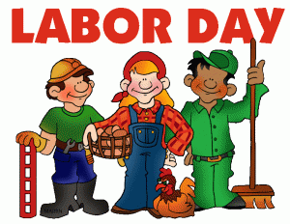  Closed | 5. | 6. | 7.  7-8pm  Preschool Open House  Wear your Red for the Chiefs!! | 8. | 9.
10.  Welcome to my world- Outer Space  Letter: Hh | 11.  Grandparents Week | 12.  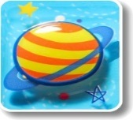 | 13.  Grandparent Breakfast  7:30-9:00am | 14. | 15.  Grandparent  Snack/Craft  3:00-3:30pm | 16.  Parent’s Night Out!  4pm-8pm
17.  Author Study: Bill Martin Jr.  Letter: Review Ll,Tt,Hh | 18.  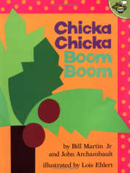 | 19.  National Talk like a Pirate Day | 20.  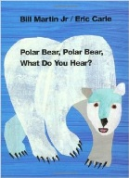 | 21.  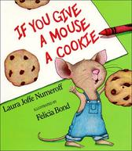 | 22.  Elephant Appreciation Day | 23.
24.  Down on the Farm  Letter: Ii | 25. | 26.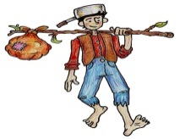  Johnny Appleseed’s Birthday | 27.  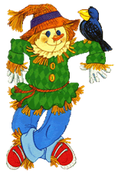 | 28. | 29. | 30.

