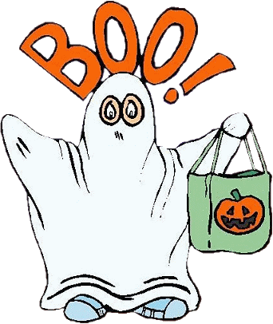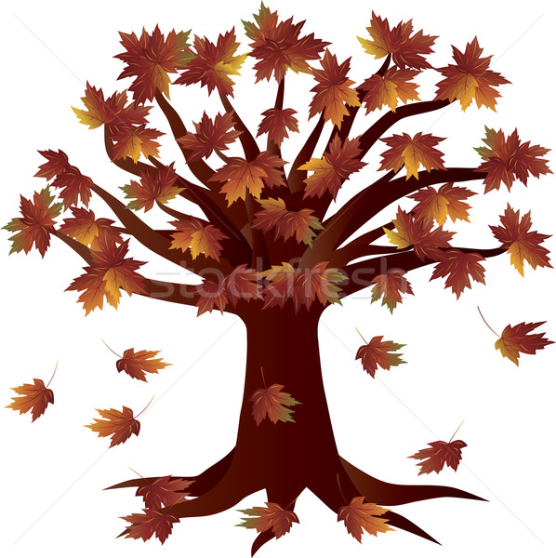

October 2016
Sunday | Monday | Tuesday | Wednesday | Thursday | Friday | Saturday
2.  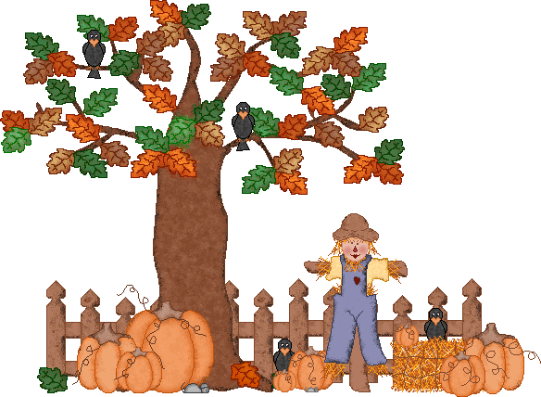Fall Harvest  Color : Orange  Letter: Ii | 3.  Shape Oval  Numbers:4,5,6 | 4. | 5. | 6.  National Noodle Day | 7. | 8.
9.  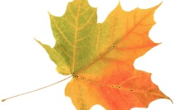  Fall Harvest  Letter: Ff | 10.  Columbus Day | 11. | 12. | 13. | 14.  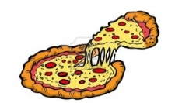  National Pizza Month | 15.  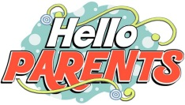  Parens Night Out  4-8 pm.
16.  Imagination  Letter: Ee | 17. | 18.  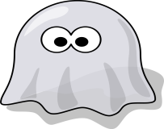 | 19 | 20. | 21.  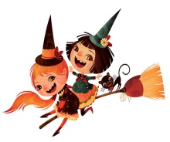 | 22..
23.  Imagination  Review: Ll,Tt,Hh,Ii,Ff,Ee | 24.  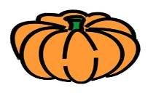 | 25.. | 26. | 27.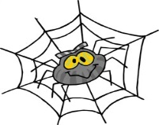 | 28.  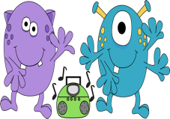 | 29.
30  Creative: Chefs  Letter: Xx | 31  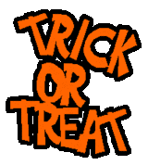  Halloween Parade & Party TBD |  |  | .

