February 2017
Sunday | Monday | Tuesday |  | Wednesday | Thursday | Friday | Saturday
Color: Pink  Shapes: Heart & Pentagon  Numbers: 13,14,15 |  | Theme:  Mad  Scientist | 1. |  | .2.  Ground  Hog Day | 3. | 4.
5.  Theme:  Healthy Bodies  Review: A,K,M,W | 6. | 7.  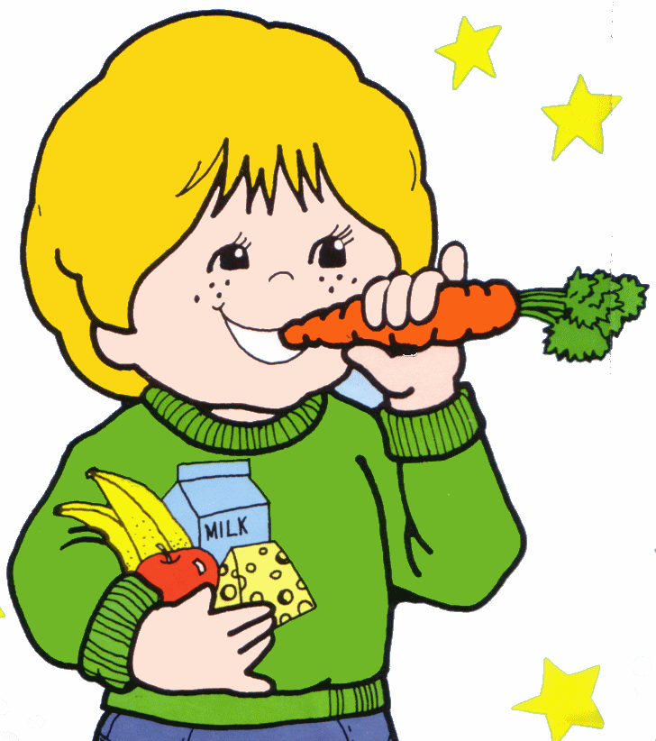 |  | 8. | 9. | 10..  Dentist Visit  EP 10:00  3s & 4s 10:30 | 11.  Parents  Night Out  4-8 pm
12  Abraham Lincoln’s Birthday  Theme:  Red Hearts  & Love Letters  Letter: Dd | 13. | 14.  Valentine’s Day & Parties |  | 15. | 16. | 17. | 18.
19.  Theme:  Treats For Sale  Letter: Pp | 20. | 21. |  | 22 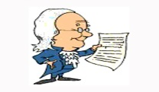  George Washington’s Birthday | 23. | 24. | 25.
27.  Theme:  Dr.Suess  Letter: Bb | 28.  Mardi Gras Starts

